**CROP YIELD PREDICTION**

Agriculture is the pillar of the Indian economy and more than 50% of India’s population are dependent on agriculture for their survival. Variations in weather, climate and other such environmental conditions have become a major risk for the healthy existence of agriculture. Machine learning(ML) plays a significant role as it has decision support tool for Crop Yield Prediction (CYP) including supporting decisions on what crops to grow and what to do during the growing season of the crops.

**Algorithms that can be used:**

1. Random Forest
2. KNN
3. Naive Bayes
4. Support vector Machines etc.

**Data-set: (Crop Production India)**

https://www.kaggle.com/datasets/abhinand05/crop-production-in-india

**Diagram:**

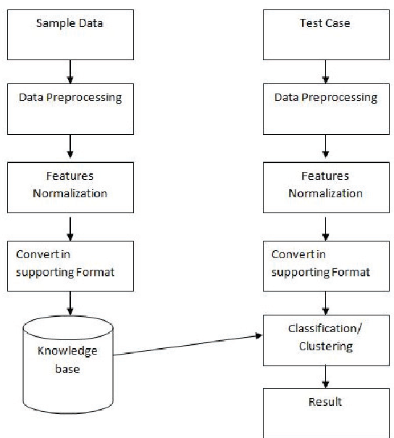

**Name: Nishanka Dutta.**

**Roll No: 2005245.**